1. **Farby z ovocia**

1. **Príklady bioproduktov**

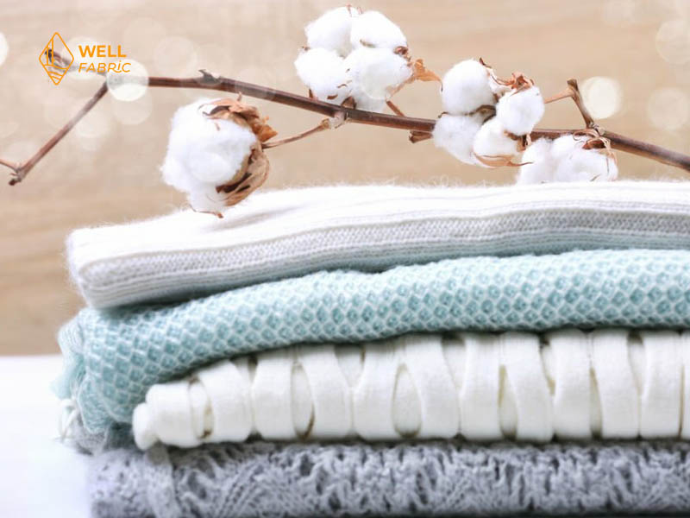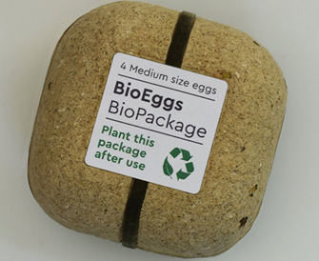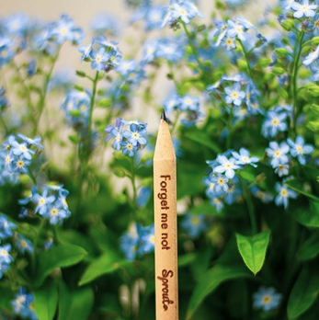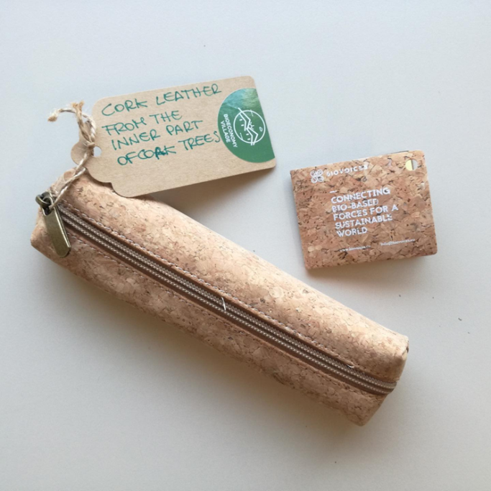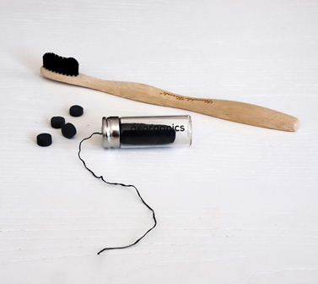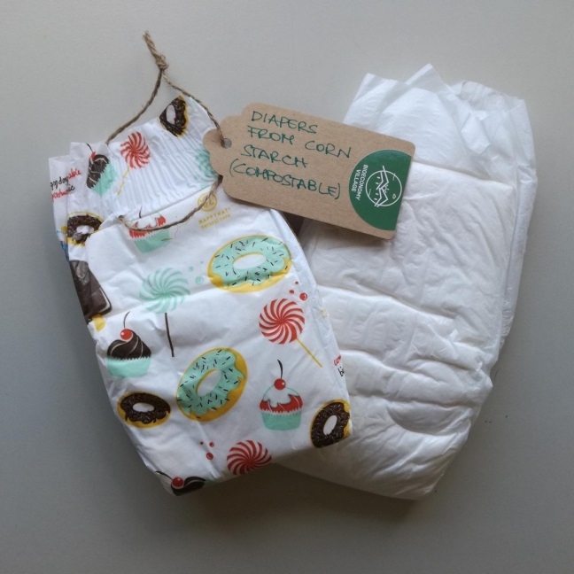

**C. Nakreslite svoje bioprodukty!**

|  |  |
| --- | --- |
| Zdroj | Produkt |
| **Príklad: bavlna**Cotton Drawing PNG Transparent Images Free Download | Vector Files | Pngtree | Cotton-jersey t-shirt technical fashion illustration with crew neckline,  elbow sleeves, oversized, dropped shoulders. Flat outwear basic apparel  template front, white color. Women men unisex top CAD Stock Vector Image &  Art - |
|  |  |
|  |  |