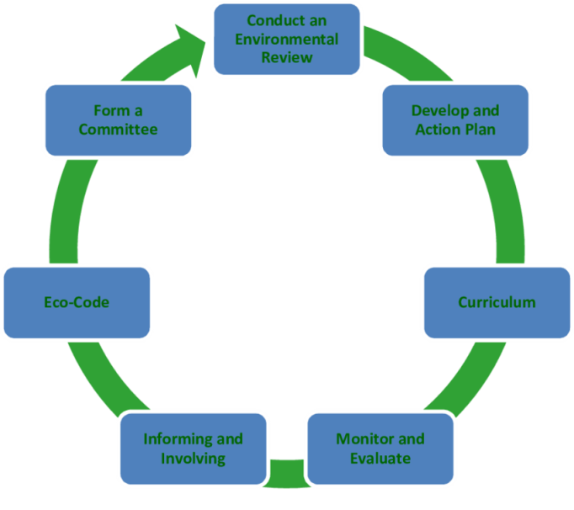

**Brainstorming sobre as 7 etapas**